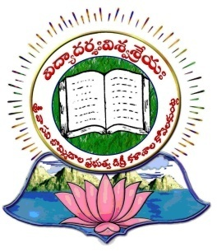
SVB GOVT. DEGREE COLLEGE
KOILKUNTLA, NANDYALA Dist., Andhra Pradesh
Reaccredited with NAAC B++ Grade
September 2023- NEWS LETTER
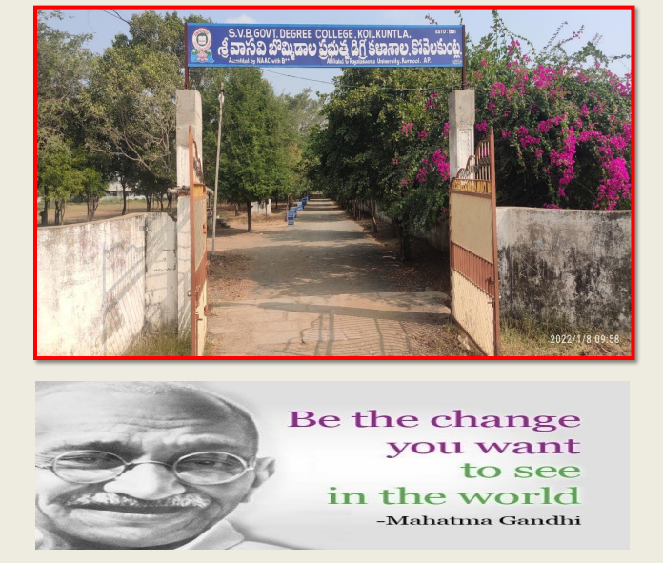
SVB Govt. Degree College
Koilkuntla, Nandyala Dist., Andhra Pradesh
Reaccredited with NAAC B+ + Grade
September - 2023
Newsletter
Editorial Board:
Chief Editor: Dr. H. Rama Subba Reddy
Editor: Sri E.V.Bhaskara Reddy

Contents:
- Principal’s message
- Free Books distribution
- National Teachers day
- Short-term Internships
- Health Check up Camp
- National Engineers day
- World Ozone day
- Faculty Forum Lecture
- NSS Formation day
- Swatchatha hi seva
- Bhagat Singh Birth anniversary
- Haritha Haram

Principal’s Message

Dear Colleagues, Students, Parents, Alumni and well wishers,
Warm greetings to you all.

It is a matter of immense pleasure for every one of us at SVB Govt. College, Koilkuntla that we are bringing out the issue of our College News Letter for the month of September 2023.

It is true that an educational institution cannot be an island unto itself. It has to find ways to connect itself to the society it intends to serve. We, the new team of faculty at the College, strongly feel that this News Letter would act as a bridge between the outside society and the Institution. We believe that the sound of the “Koil Bells” would be heard far and wide.

This News Letter covers a wide spectrum of Curricular, co-curricular and Extra-curricular activities carried out by the various departments of the College in the month of September 2023. I whole heartedly congratulate the editorial board for their sincere efforts in chronicling these events. I hope it would be appreciated by one and all.

With regards
Dr. H.Ramasubba Reddy

About the College

S.V.B. Govt. Degree College, Koilkuntla is in the vicinity of historically well-known Renadu area in Kurnool district in Rayalaseema of Andhra Pradesh. S.V.B. Govt. Degree College was established at Koilkuntla under the aegis of Late Sri Pendekanti Venkata Subbaiah, former Governor of Bihar and Karnataka, in 1981. The main objective was to develop this area educationally. About 85% of students hail from socially disadvantaged communities with low income levels. Conventional and restructured courses are offered in this college. The introduction of all courses is giving a greater opportunity for students of this educationally backward area. The CPDC (College Planning and Development Council) and Alumni are a great source of strength to this college. S.V.B. Govt. Degree College moulds the students as responsible citizens and strives to impart employable skills to them. The college has gone for accreditation by NAAC, Bangalore and got B+ Grade in 2007. It went for reaccreditation in 2015 (Second Cycle) and secured B++ Grade.

Vision & Mission

To empower students of first generation families from marginalized sections with 21st century requirements of the society through quality education

Note Books distribution
Date: 01.09.2023
Organised by: Dept. of Zoology

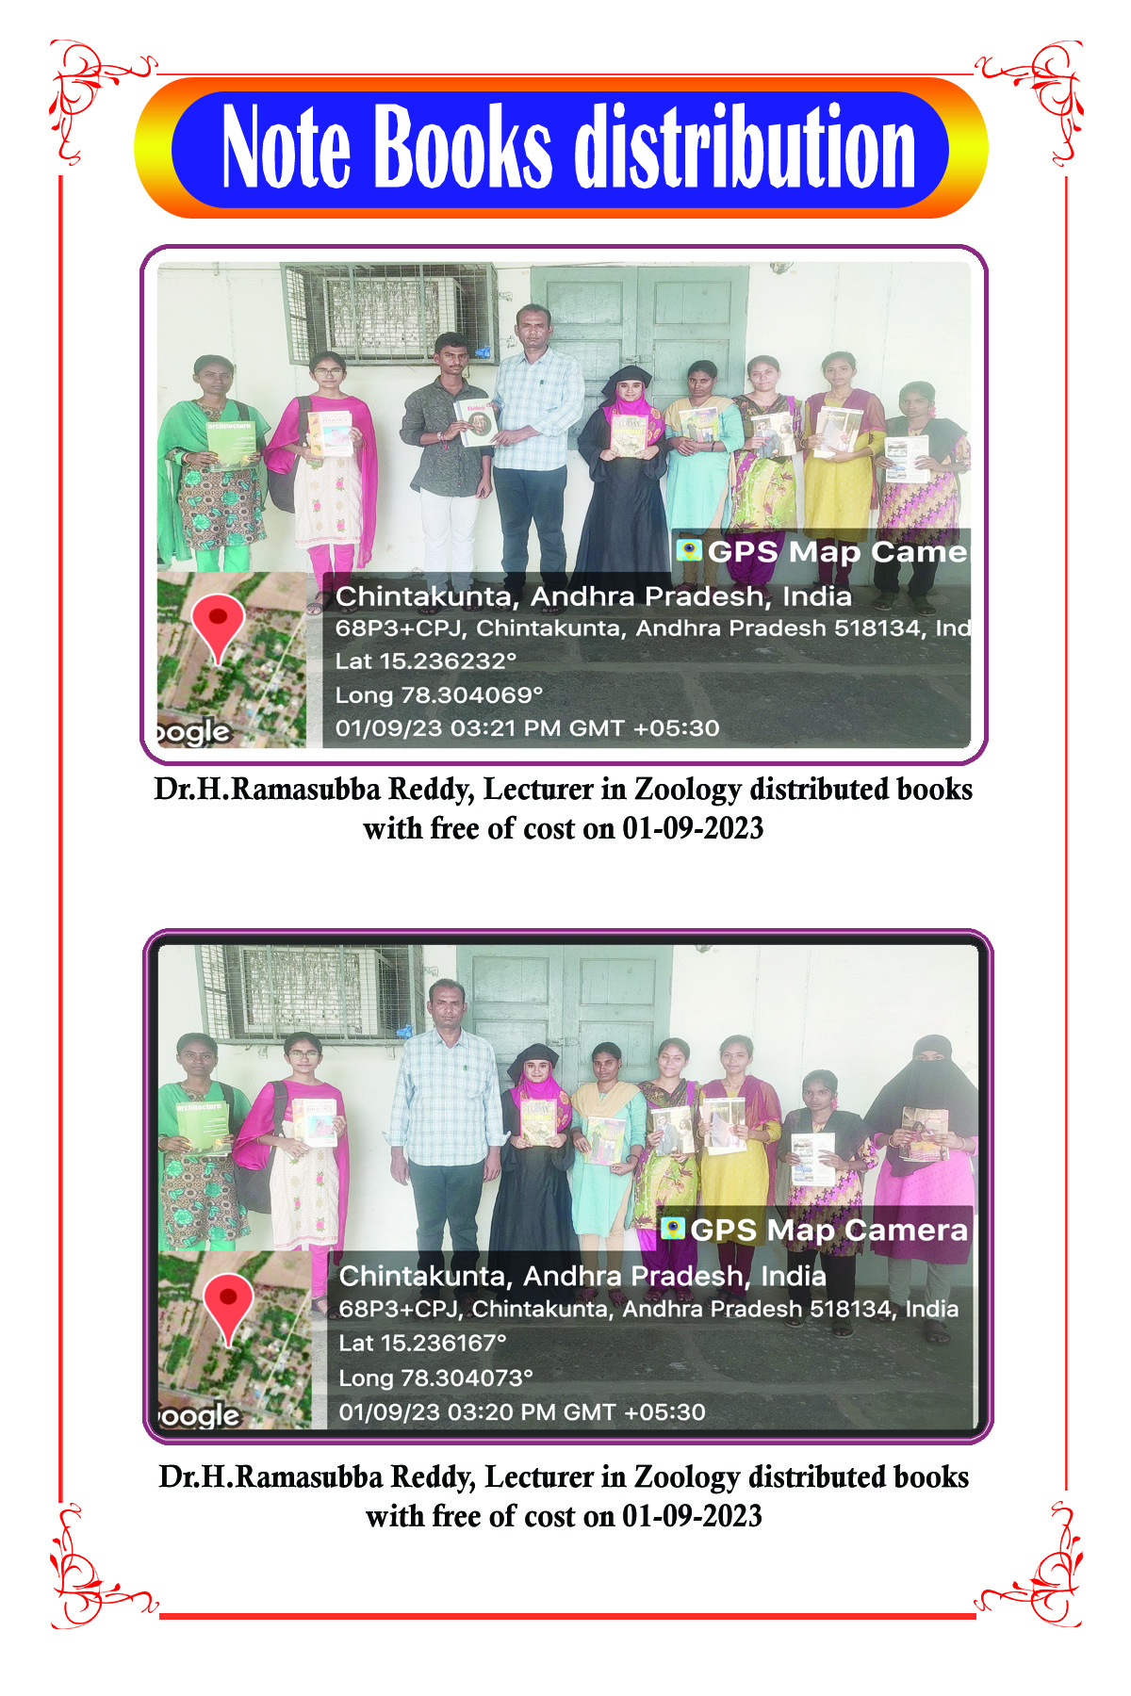

National Teachers day
Date: 05.09.2023
Organised by: Dept. of Telugu
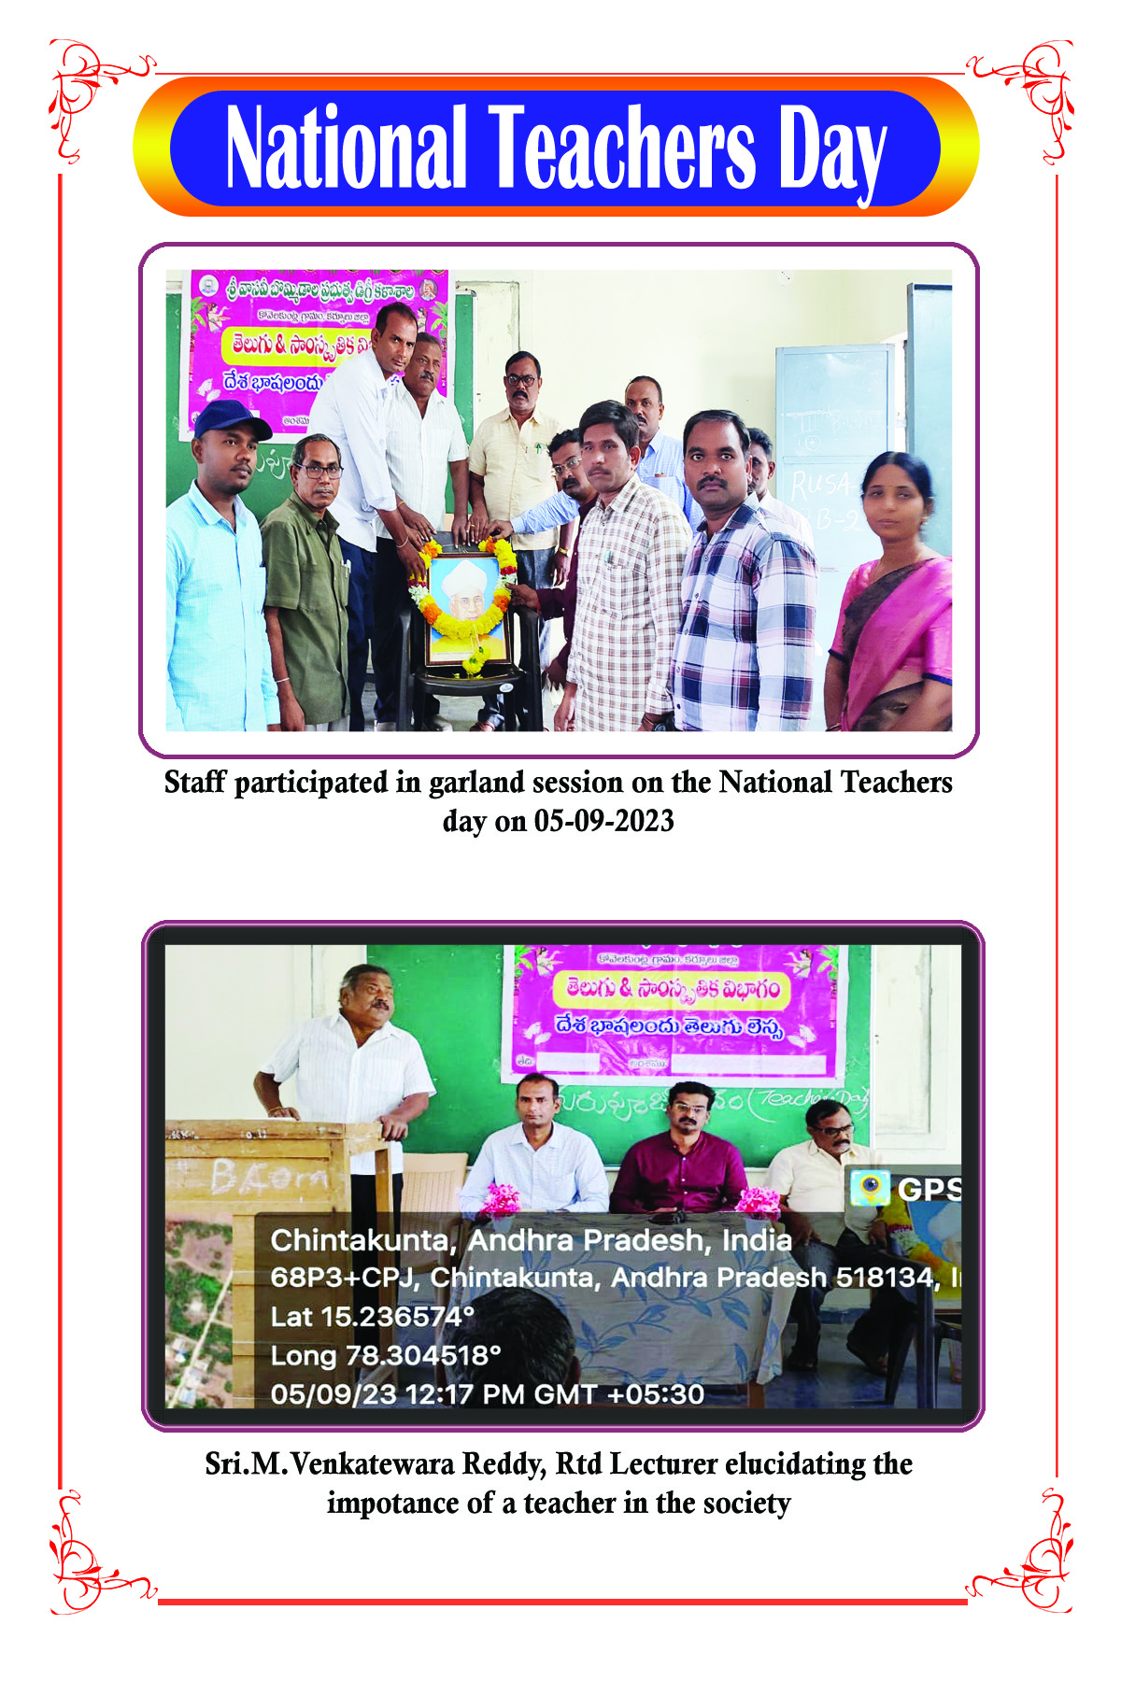
Short-term Internships
Date: 08.09.2023
Organised by: Dept. Of Chemistry

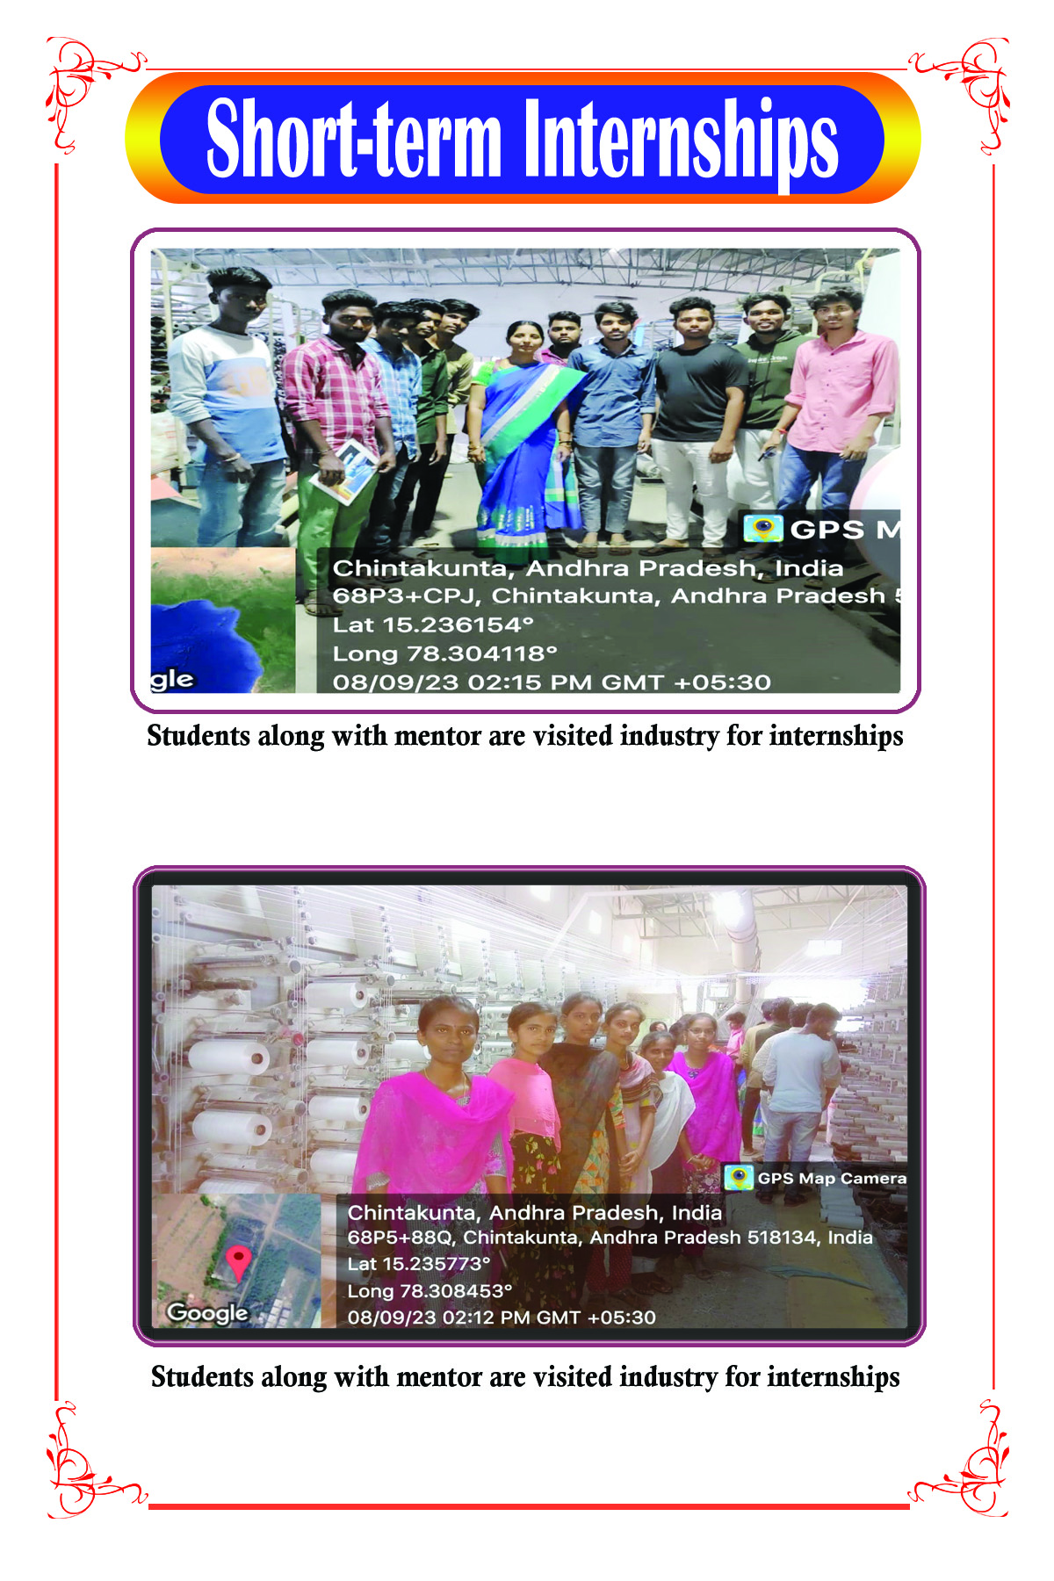

Health Check up Camp
Date: 12.09.2023
Organised by: Dept. Of Zoology

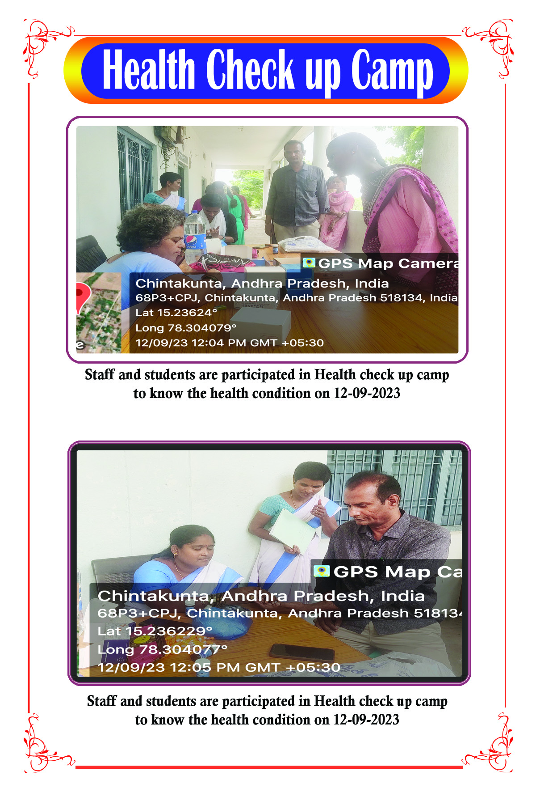
National Engineers day
Date: 15.09.2023
Organised by: Dept. of Physics

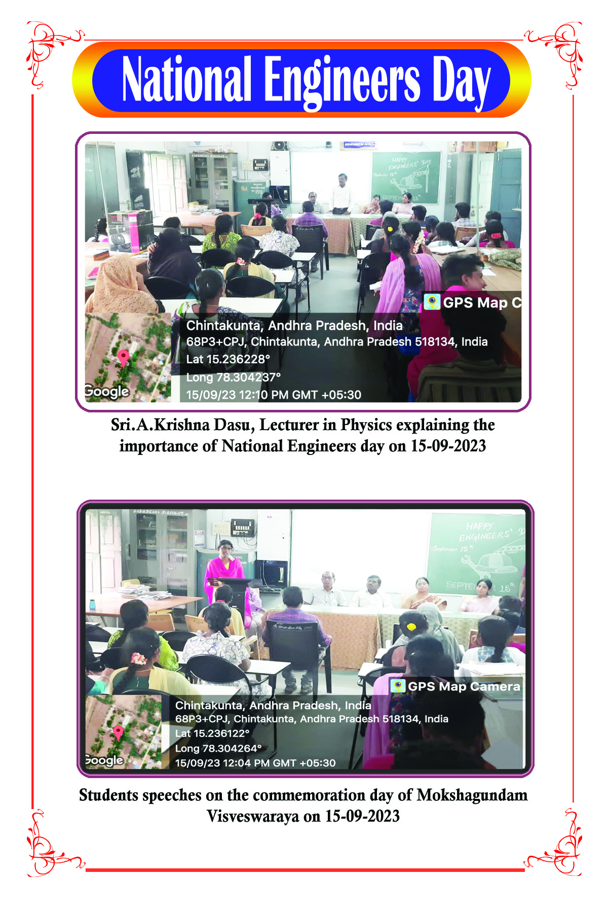
World Ozone day
Date: 16.09.2023
Organised by: Dept. of Chemistry

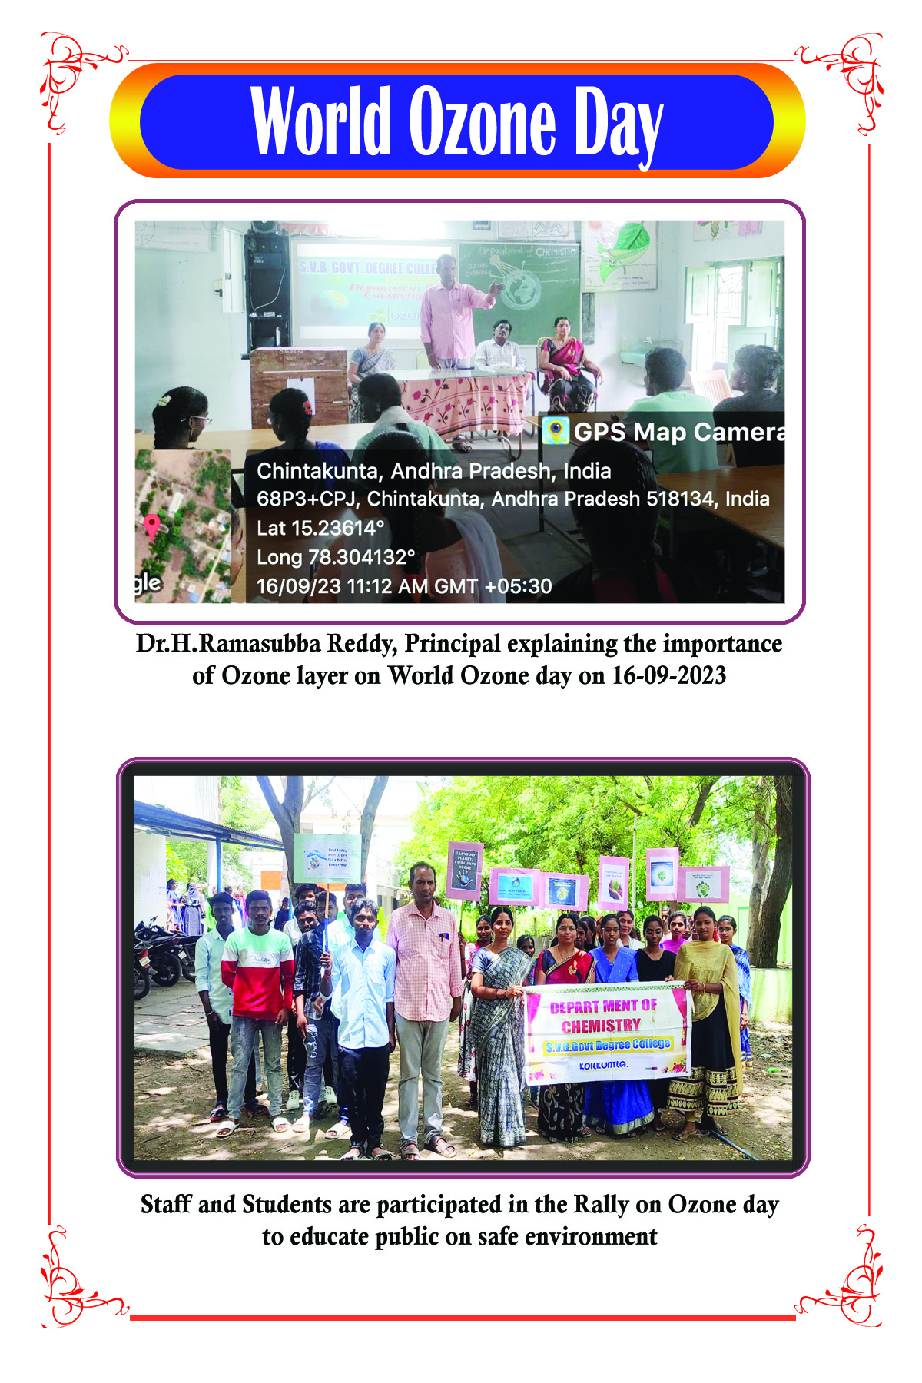
Faculty Forum Lecture
Date: 23.09.2023
Organised by: Faculty Forum

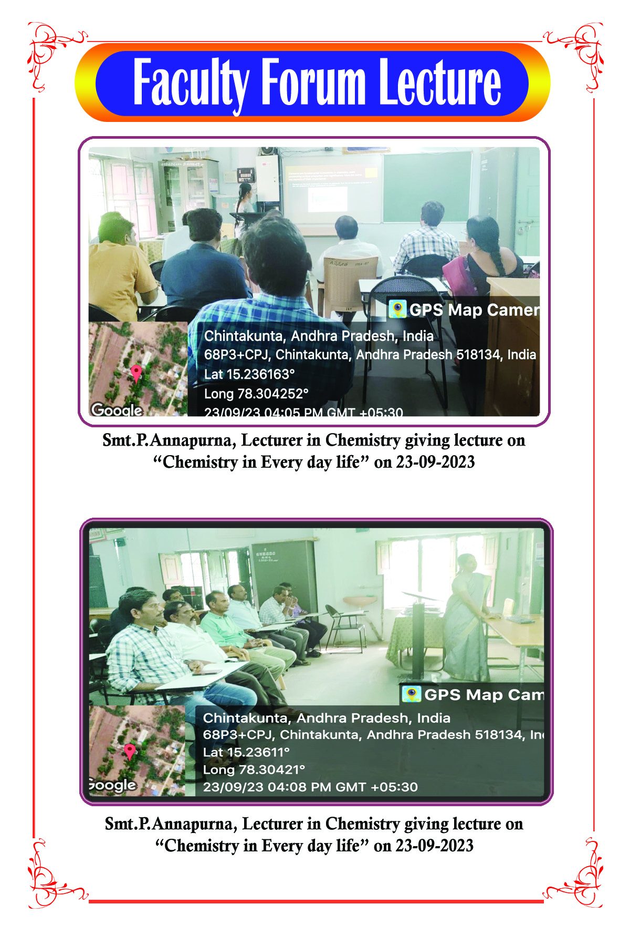
NSS Formation day
Date: 24.09.2023
Organised by: NSS

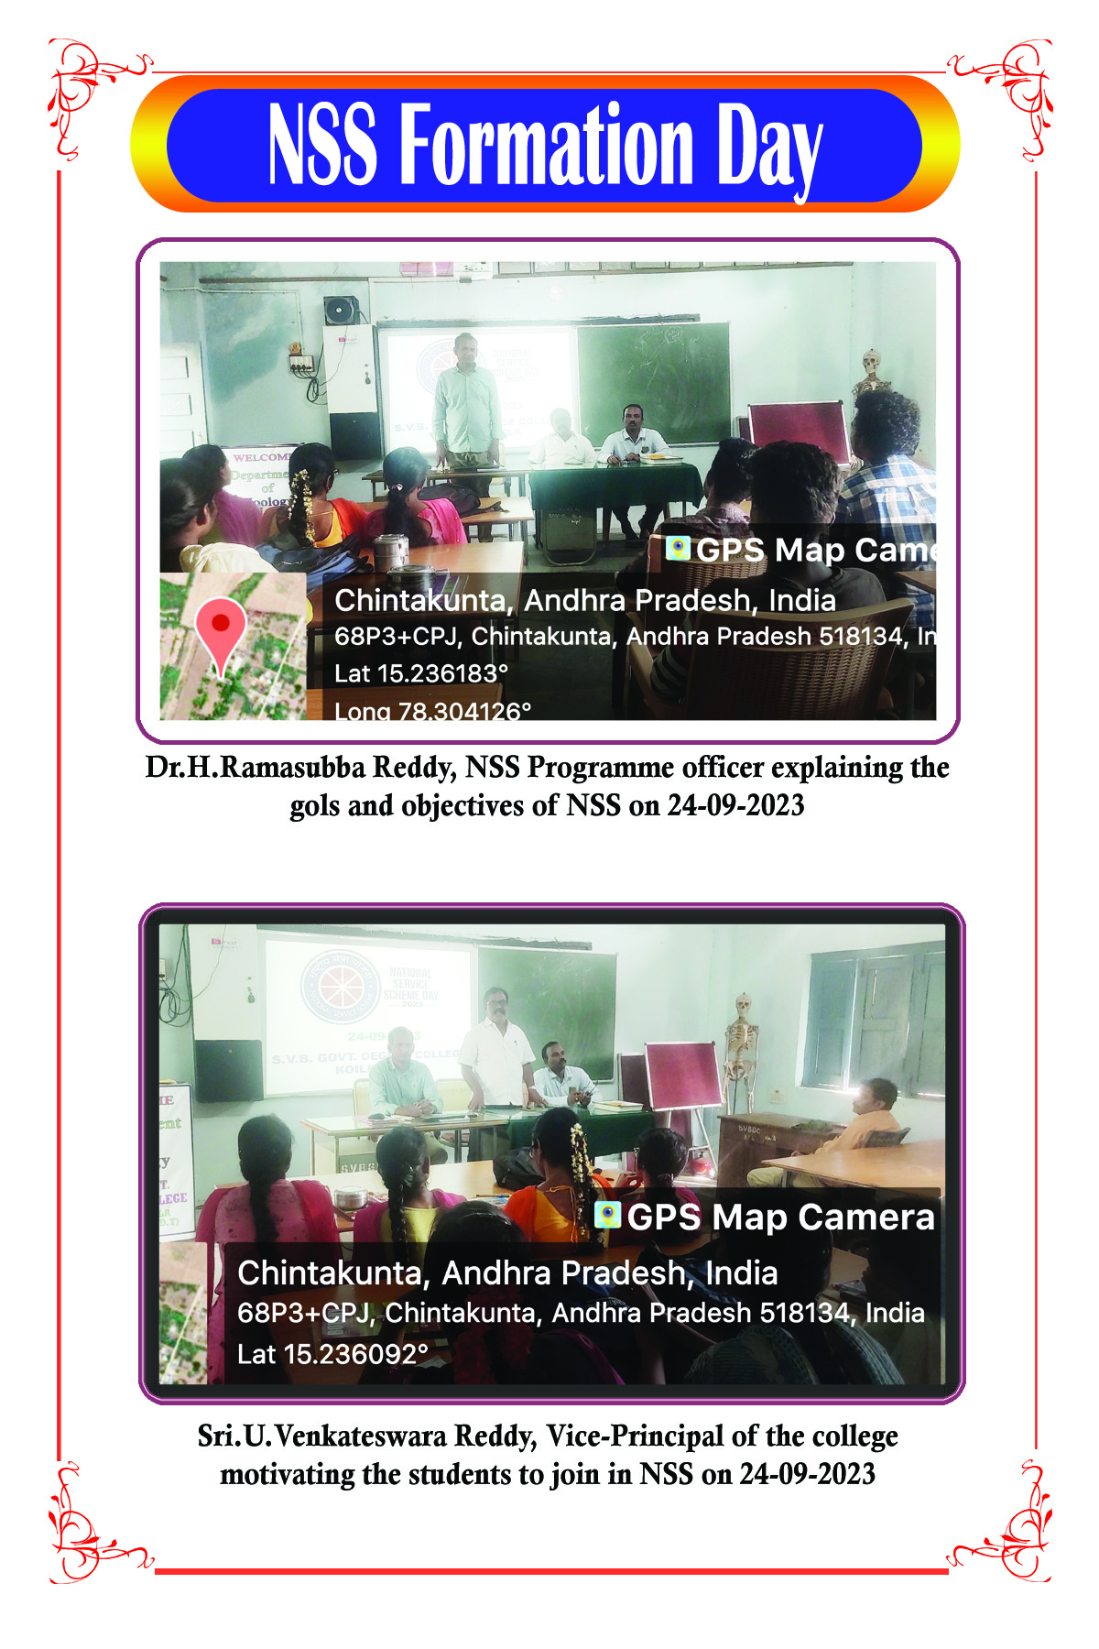
Swatchata hi seva
Date: 26.09.2023
Organised by: NSS.

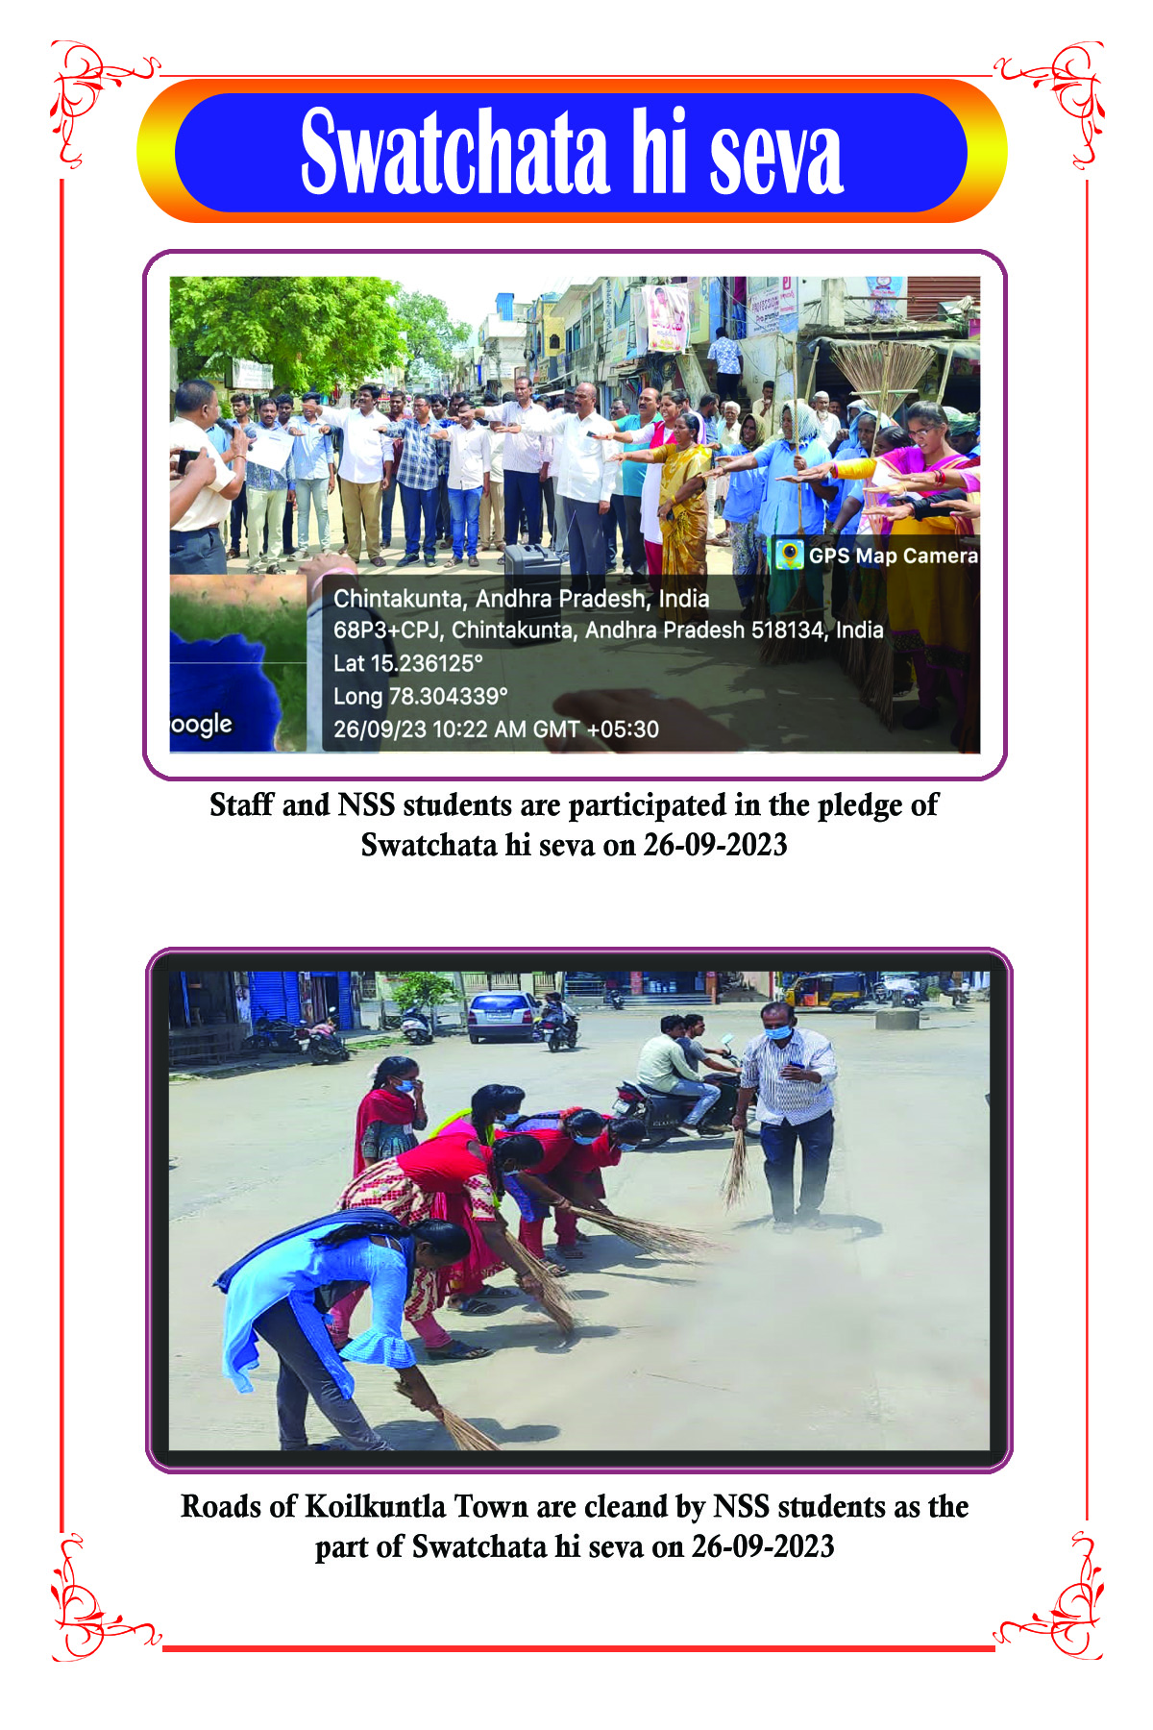
Bhagat Singh Birth Anniversary
Date: 27.09.2023
Organised by: Dept. of History

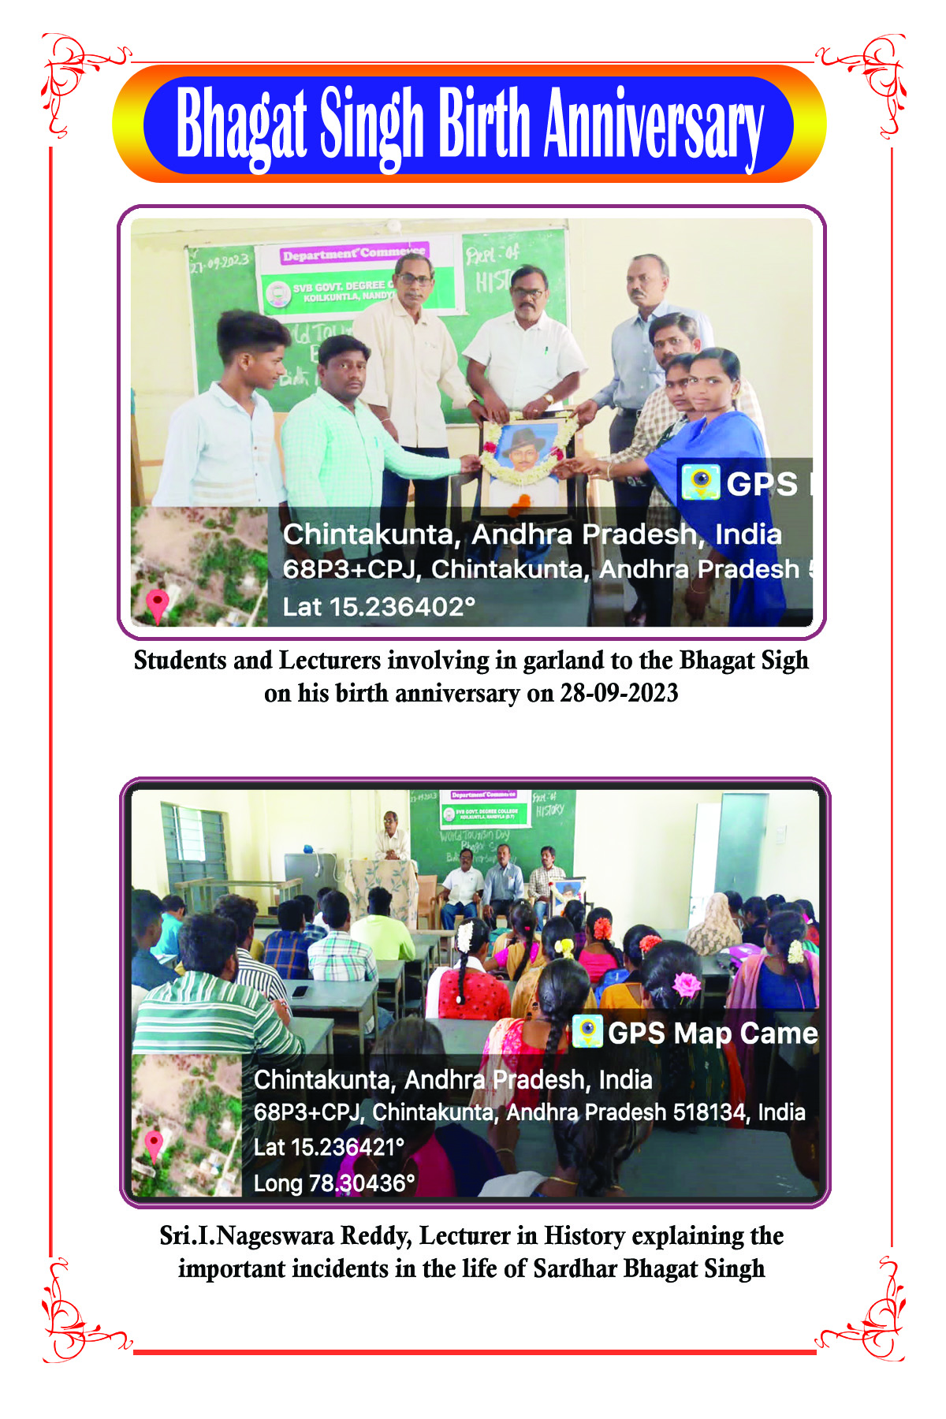
Haritha Haram
Date: 30.09.2023
Organised by: Eco Club

